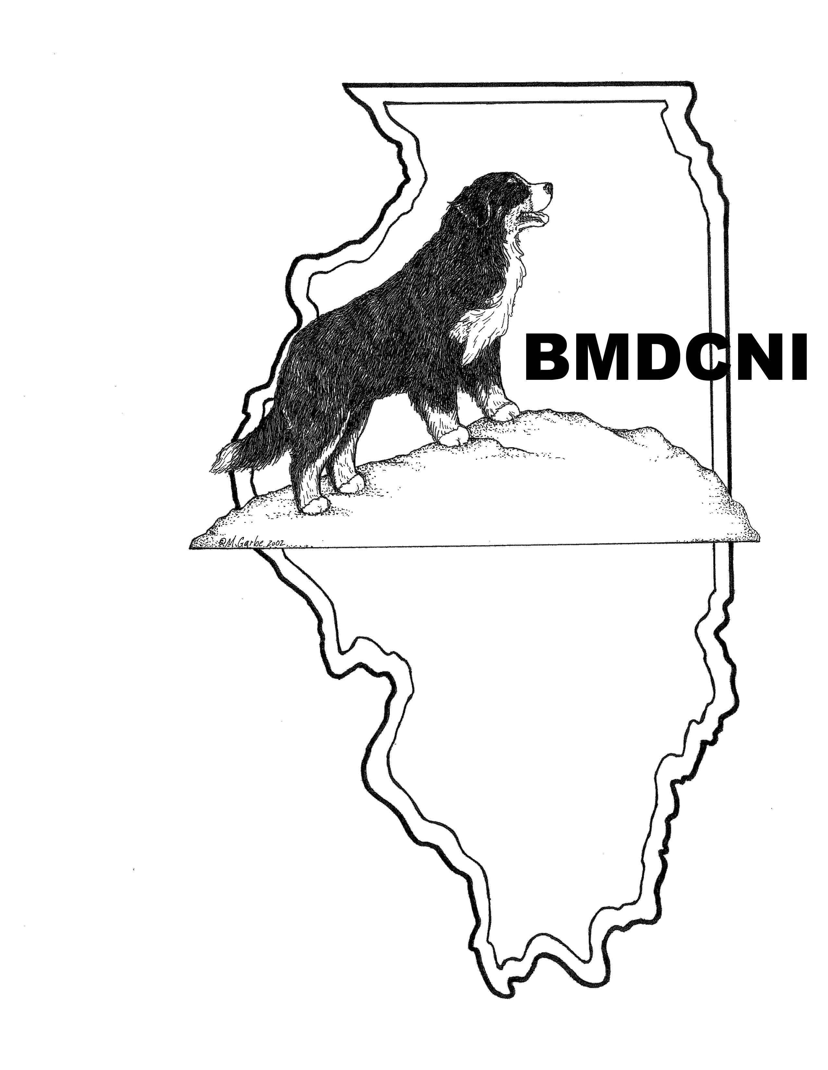
DUES RENEWAL NOTICE
Check #________
Date___________
Due by January 1st, 2024
Please print, fill out this form, sign the updated Code of Ethics and mail with dues to
Lynne Washburn, 2381 N 4070th Road, Sheridan, IL 60551.
Please email the membership chair at highlandsbmd@gmail.com if you have any questions.
PLEASE CHECK IF THERE ARE CHANGES TO YOUR INFORMATION
Name(s)_________________________________________________________________________
Kennel Name_____________________________________________________________________
Address_________________________________________________________________________
City__________________________________________State__________Zip Code_____________
Best Phone Number_____________________________________________ ( ) Home or ( ) Cell
Primary Member Email address_____________________________________________________
Alternate Email address___________________________________________________________
Please check all that apply:
( ) Owner ( ) Exhibitor
( ) Breeder ( ) Conformation
( ) Obedience ( ) Rally
( ) Agility ( ) Tracking
( ) Herding ( ) Therapy
( ) AKC/BMDCA Judge ( ) Rescue
( ) Scent work ( ) Drafting

MEMBERSHIP RENEWAL DUES:
( ) Voting Family $25.00 ( ) Voting Individual $20.00
I plan to attend at least one meeting event and would like to have input
into the direction and activities of the club. (Keep in mind we need a quorum
at a meeting to vote on items so please consider Non-Voting if you do not
attend meetings)

( ) Associate Family $20.00 ( ) Associate Individual $15.00
I probably will not attend meeting events but am interested in
belonging to a Regional BMD Club.

( ) Junior (10-17yrs) NO CHARGE

( ) Surcharge for Paper copy of Matterhorn Newsletter MAILED: $15.00

PLEASE CONSIDER MAKING A DONATION TO:
( ) General Fund $__________ ( ) Trophy Fund $__________
Total Amount Enclosed $__________ (Make Check Payable to BMDCNI)

Bernese Mountain Dog Club of Northeastern Illinois
Code of Ethics

- Breeders shall strive for perfection of the Bernese Mountain Dog in accordance with the official standard set forth by the American Kennel Club. In this regard they shall:
  - Maintain high standards of health and care for their dogs.
  - Use only physically and temperamentally sound stock and refuse stud service to any bitch that is unregistrable or shows obvious defects. They shall study and learn the good and bad points within their own stock never doubling up on a known and visible fault.
  - X-ray for evidence of hip dysplasia at two years of age or older, treating mild cases as they would any other fault, and excluding from breeding programs dogs with more severe evidence of hip dysplasia.

  - X-ray for evidence of elbow dysplasia at two years of age or older, treating mild cases as they would any other fault, and excluding from breeding programs dogs with more severe evidence of elbow dysplasia.

  - Ideally, certify all dog’s for Eyes, Heart, Von Willebrand Disease (vWD), and Degenerative Myelopathy (DM) SOD1A & SOD1B.

  - Refrain from breeding the bitch until her second season, preferably waiting until at least 18 months of age. A bitch shall be bred no more than two out of three seasons, this depending on the size of the litter whelped and her condition. It is suggested that in most cases a period of one-year lapse between litters.
- Breeders will not sell adults or puppies without true representation to the purchaser nor use misleading or untruthful statements in selling or advertising.
- No member shall sell adults or puppies to retail or wholesale pet stores, commercial breeders, Berner Doodle breeders or other breeders of mixed breeds.

- Breeders will sell all adults and puppies via a signed contract that requires the breeder to take back any sold puppy or adult dogs and ensure all adults and puppies are registered with the AKC.
- A buyer should be supplied with a four-generation pedigree, with information on inoculations and other veterinary care that the dog has had, and with instructions on the care, feeding and training of the Bernese Mountain Dog.
- A breeder should guarantee the health of their dogs subject to a veterinarian’s examination within two working days of the sale.
- A breeder should try to keep in touch with the progress of dogs, of their breeding, in order to better analyze their own program.
- A breeder will enter health and certification information, of dogs they have bred into the BernerGarde database.

- A breeder shall exhibit at dog shows and matches where feasible.
- Members shall at all times exhibit good sportsmanship at all events related to the club and dog shows.
- Members shall not degrade any other member or kennel.

Applicant(s) Signature(s): |  |  |  | Date:
Membership Chair’s Signature: |  |  |  | Date:

